

## 

**FITZONE - GYM TRAINER AND PROGRESS**

## TRACKER APPLICATION

## 21SBE04 - USER EXPERIENCE DESIGN

## A PROJECT REPORT

***Submitted by***

## KISHORE S 727821TUAD027

***in partial fulfilment for the award of the degree***

***Of***

## BACHELOR OF TECHNOLOGY

## IN

## ARTIFICIAL INTELLIGENCE AND DATA SCIENCE

**NOVEMBER 2023**



## BONAFIDE CERTIFICATE

Certified that this project report **“FITZONE – GYM TRAINER AND PROGRESS TRACKER APPLICATION”** is the bonafide work of “**KISHORE S , DHARMAPRAKASH G and JAYANDRA MUGILAN R A”** who carried out the project work under my supervision.

**SIGNATURE SIGNATURE**

**Dr. R. KARTHIK Dr. C. P. MAHESWARAN**

**SUPERVISOR HEAD OF THE DEPARTMENT**

Associate Professor, Professor,

Department of Computer Science and Department of Artificial Intelligence

Engineering (Cyber Security), and Data Science,

Sri Krishna College of Technology, Sri Krishna College of Technology,

Coimbatore-641042. Coimbatore-641042.

Certified that the candidates were examined by us in the Project Viva Voce examination held on at Sri Krishna College of Technology, Kovaipudur, Coimbatore - 641042.

**INTERNAL EXAMINER EXTERNAL EXAMINER**

**ACKNOWLEDGEMENT**

Dedicating this project to the **ALMIGHTY GOD** whose abundant grace and mercies enabled its successful completion.

We extend our deep gratitude to our Principal, **Dr. M. G. Sumithra,** for her kindness and unwavering support throughout the project work.

We are grateful to our beloved Dean Academics affairs and assessment **Dr. R. Rameshkumar,** for his tireless and relentless support.

We extend our heartfelt thanks to our beloved Dean Accreditation and ranking **Dr. P. Manju,** for her advice and ethics inculcated during the entire period of our study.

We would like to express our deep gratitude to **Dr. J. Shanthini,** Head of Computing Science and **Dr. C. P. Maheswaran,** Head of Artificial Intelligence and Data Science, for their exceptional dedication and care towards success of this project.

We would like to extend our gratitude to our project guide **Dr. R. Karthik**, Associate Professor, Department of Computer Science and Engineering (Cyber Security) for his valuable guidance and suggestions in all aspects that aided us to ameliorate our skills.

We are thankful to all those who have directly and indirectly extended their help to us in completing this project work successfully.

**ABSTRACT**

In a world increasingly conscious of health and fitness, the need for a comprehensive and user-friendly gym application has never been more apparent. This report outlines the process of conceptualizing, designing, and developing a state-of-the-art Gym Application, catering to the needs of fitness enthusiasts, gym owners, and trainers. The Gym Application is envisioned as a versatile tool, encompassing features such as workout tracking, personalized training plans, nutrition guidance, and social connectivity, making it a one-stop solution for the fitness community. The project's scope ranges from defining the application's core functionality to designing an intuitive user interface, choosing the right technology stack, and implementing a secure and scalable infrastructure. The Gym Application's development process is documented in stages, from initial ideation and requirement gathering to coding, testing, and deployment. Emphasis is placed on the agile development methodology, ensuring flexibility and adaptability to evolving user needs and industry trends. The Gym Application's ultimate goal is to contribute to a healthier society by making fitness accessible and enjoyable, promoting a lifestyle that embraces well-being. The report provides an in-depth view of this innovative project, shedding light on the intersection of technology, health, and human motivation.

# LIST OF FIGURES

|  |  |  |
| --- | --- | --- |
| FIG.NO | FIGURE NAME | PAGE NO |
| 5.1 | Use Case Diagram | 12 |
| 5.2 | Sequence Diagram | 13 |
| 6.1 | Login Page | 18 |
| 6.2 | Home Page | 19 |
| 6.3 | Workout Category Page | 19 |
| 6.4 | Exercise Page | 20 |
| 6.5 | Sample Videos Page | 20 |
| 6.6 | Help and Support Page | 21 |

**LIST OF ABBREVIATIONS**

|  |  |
| --- | --- |
| **ABBREVIATIVE** | **ABBREVIATION** |
| CSS | CASCADING STYLESHEET |
| JS | JAVASCRIPT |
| HTML | HYPERTEXT MARKUP LANGAUGE |
| API | APPLICATION PROGRAMMING INTERFACE |
| UI/UX | USER INTERFACE / USER EXPERIENCE |

# TABLE OF CONTENTS

|  |  |  |
| --- | --- | --- |
| **CHAPTER**  **NO** | **TITLE** | **PAGE**  **NO** |
|  | **ACKNOWLEDGEMENT** | **III** |
|  | **ABSTRACT** | **IV** |
|  | **LIST OF FIGURES** | **V** |
|  | **LIST OF ABBREVIATIONS** | **VI** |
| **1** | **INTRODUCTION** | 1 |
| 1.1 | PROBLEM STATEMENT | 2 |
| 1.2 | OVERVIEW | 2 |
| 1.3 | OBJECTIVE | 2 |
| 1.4 | SCOPE | 3 |
| **2** | **LITERATURE SURVEY** | 4 |
| **3** | **SYSTEM SPECIFICATIONS** | 6 |
| 3.1 | SPRING BOOT | 6 |
| 3.2 | REACT | 7 |
| 3.3 | MYSQL | 7 |

|  |  |  |
| --- | --- | --- |
| 3.4 | VS CODE | 7 |
| 3.5 | LOCAL STORAGE | 8 |
| 3.6 | ROUTERS IN REACT | 8 |
| 3.7 | REACT REDUX | 9 |
| 3.7 | TECHNOLOGY STACK | 9 |
| **4** | **PROPOSED SYSTEM** | 10 |
| 4.1 | OVERVIEW | 10 |
| 4.2 | KEY FEATURES | 10 |
| **5** | **DESIGN AND METHODOLOGIES** | **12** |
| 5.1 | USE CASE DIAGRAM | 12 |
| 5.2 | SEQUENCE DIAGRAM | 13 |
| 5.3 | METHODOLOGIES USED IN OUR APP | 14 |
| 5.4 | ENROLLMENT PHASE | 14 |
| 5.5 | NAVIGATION PHASE | 15 |
| 5.6 | MICROSERVICE PHASE | 16 |
| **6** | **IMPLEMENTATION AND RESULT** | 17 |
| 6.1 | LOGIN | 17 |

|  |  |  |
| --- | --- | --- |
| 6.2 | HOMEPAGE | 18 |
| 6.3 | WORKOUT CATEGORY PAGE | 18 |
| 6.4 | EXERCISE PAGE | 19 |
| 6.5 | SAMPLE VIDEOS PAGE | 19 |
| 6.6 | HELP AND SUPPORT PAGE | 20 |
| 6.7 | CODING | 20 |
| **7** | **CONCLUSION** | 24 |
| 7.1 | FUTURE SCOPE | 25 |
|  | REFERENCES | 26 |

**CHAPTER 1 INTRODUCTION**

The Gym Application is a complete fitness ecosystem, designed to adapt to our unique needs and goals. Whether you're an early bird hitting the gym, a busy professional seeking quick home workouts, or a weekend warrior exploring new routines, this app accommodates our lifestyle.

Our seamless wearable integration allows you to sync favorite fitness trackers, ensuring that you get the most accurate and comprehensive data on our physical activity and health stats. Plan our workouts in advance, set reminders, and establish a consistent routine with the Workout Scheduler feature.

It's the key to maintaining our commitment and achieving long-term success. Moreover, our achievement badge system rewards our dedication and perseverance, giving you a sense of accomplishment with each milestone you reach.

Let's make our health and fitness dreams a reality. This dynamic and user-friendly application is designed to cater to the needs of both fitness enthusiasts and professional gym trainers, making the pursuit of fitness goals more effective, engaging, and efficient than ever before.

This application offers a comprehensive platform to curate and deliver personalized training programs that are precisely tailored to their clients' unique fitness aspirations, body types, and preferences. It provides a suite of features for tracking, analyzing, and optimizing the progress of clients, ensuring that trainers can continuously refine their coaching to help clients achieve their goals.

## PROBLEM STATEMENT

To build a Gym Trainer and Progress Tracker Application using React for Frontend, Spring Boot Microservices for Backend, and MySQL for database.

## OVERVIEW

The Gym Application is our all-in-one solution for achieving our fitness goals and embracing a healthier lifestyle. With its personalized workouts, exercise instructions, and a vast array of nutrition guidance, it ensures you have the tools and knowledge to succeed in our fitness journey. Real-time progress tracking keeps you accountable and motivated, allowing you to see our achievements unfold before our eyes. It will make our health and wellness aspirations a reality.

## OBJECTIVE

The primary objective of the Gym Application is to empower individuals to achieve their fitness and wellness goals effectively and efficiently by providing a comprehensive, user-friendly, and personalized fitness platform. The application aims to offer tailored workout routines, expert guidance on exercise and nutrition, real-time progress tracking and a supportive help. The ultimate goal is to inspire and assist users, regardless of their fitness level or background, in their pursuit of a healthier and more active lifestyle, ultimately leading to get better fitness.

## 1.4 SCOPE

The scope of this project includes the development of both frontend and backend components of the application. This encompasses the user interface, user database, authentication system, progress tracking functionality, workouts management, and admin dashboard for platform administrators.

**CHAPTER 2**

# LITERATURE SURVEY

In Gym applications have become a cornerstone of the digital fitness revolution, offering users an array of tools and resources that cater to their individual health and wellness needs. They empower individuals by granting them instant access to personalized workout routines, nutritional guidance, and the ability to track their fitness progress.

The reviewed literature consistently highlights the numerous advantages of these applications, including their convenience, flexibility, and potential to foster motivation. Users can access expert advice, engage with fitness communities, and experience a sense of achievement through workout tracking and achievement badges. However, challenges such as user engagement and adherence pose noteworthy hurdles. As the fitness app landscape continues to evolve, it becomes increasingly evident that in-depth research is essential to refine and enhance the user experience while addressing the identified gaps.

In this context, gym applications have the potential not only to revolutionize individual fitness journeys but also to transform the broader health and wellness landscape. The implications of these findings underscore the importance of user engagement and adherence strategies for both application developers and users alike, as we collectively pursue healthier, more active lifestyles.The literature survey on gym applications underscores their pivotal role in modern fitness and wellness. Gym applications offer a convenient and accessible means for individuals to engage in tailored workouts, access nutrition.

Research suggests that these apps hold substantial potential for motivating users and helping them reach their fitness goals. However, they also face challenges related to user engagement and long-term adherence. This survey identifies a critical need for further research in understanding and enhancing user engagement strategies and in assessing the efficacy of gym applications for specific fitness objectives and diverse user populations. In conclusion, gym applications are poised to reshape the fitness landscape, but their continued success hinges on addressing the highlighted gaps and optimizing user experiences. This literature survey sheds light on the path forward, emphasizing the importance of effective engagement and adherence strategies for developers and users alike.

A gym application encompasses a comprehensive review of existing research, studies, and literature related to the development and usage of fitness and workout applications. Numerous studies have examined the benefits of mobile applications in promoting physical activity and healthy lifestyle choices. Research has shown that such applications can significantly enhance user engagement, motivation, and adherence to fitness routines. Additionally, investigations into the design and user experience aspects of gym apps have highlighted the importance of intuitive interfaces, gamification elements, and personalized features to maximize user satisfaction and long-term usage. Furthermore, studies have explored the impact of wearable fitness technology integration with gym applications, shedding light on the potential for real-time tracking and data analysis to improve exercise outcomes. By examining this body of literature, one can gain valuable insights into the latest trends and best practices in the development of gym applications, ultimately contributing to the creation of more effective and user-friendly fitness tools.

**CHAPTER 3**

# SYSTEM SPECIFICATION

In this chapter, we are going to see the softwares that we have used to build the application. This chapter gives you a small description about the softwares used in the project.

## SPRING BOOT

Spring Boot is a Java-based framework that simplifies the development of standalone, production-ready Spring applications. It provides a convention-over- configuration approach, reducing boilerplate code and allowing developers to focus

on writing business logic. Spring Boot offers built-in features like auto-configuration, embedded servers, and dependency management, which make it easy to set up and deploy applications. Spring Boot also provides a wide range of tools and features that simplify various aspects of application development. It includes built-in support for web applications, RESTful APIs, and data access, making it easy to create end-to-end solutions. It also integrates well with other Spring frameworks and libraries, providing a comprehensive ecosystem for building enterprise - grade applications.

**3.2 REACT**

React [4] is a JavaScript library for building user interfaces. The developer

will create reusable UI components and efficiently update them when the underlying data changes. React uses a virtual DOM (Document Object Model) to optimize rendering performance and provide a smooth user experience. React is widely used for developing single-page applications, mobile applications, and progressive web applications.

## MYSQL

MySQL is a popular open-source relational database management system. It provides a reliable and scalable solution for storing and managing structured data. MySQL supports standard SQL queries and offers various features like transactions, indexing, and data replication. It is widely used in web applications to handle data persistence, allowing developers to store, retrieve, and manipulate data efficiently. MySQL integrates well with different programming languages and frameworks, making it a versatile choice for database management.

## VS CODE

Visual Studio Code is a lightweight, cross-platform source code editor developed by Microsoft. It provides a wide range of features and extensions that enhance the coding experience. VS Code supports multiple programming languages and offers features like syntax highlighting, code completion, debugging, and version control integration. It is highly customizable, allowing developers to personalize their editor with themes, extensions, and keyboard shortcuts. VS Code is widely used by developers for various web development projects, including Spring Boot and React applications.

## LOCAL STORAGE

Local storage is a web browser feature that allows websites to store data on the client's device. It provides a simple key-value storage mechanism that persists data even when the browser is closed or the device is restarted. Local storage is commonly used to store user preferences, session data, and cached data. It is accessible via the browser's JavaScript API, making it easy to read from and write to. Local storage is a secure and efficient way to store small amounts of data on the client-side, reducing the need for frequent server requests and improving overall performance.

## ROUTERS IN REACT

Routers are essential components in React applications for managing client- side routing. React Router is a popular library that provides a declarative way to handle routing in React applications. It allows developers to define different routes and associate them with corresponding components. React Router enables navigation between different views or pages within a single-page application without the need for a full page refresh. It supports dynamic routing, nested routes, and parameterized routes, providing flexibility in designing the application's navigation structure. React Router simplifies the process of handling multiple views and maintaining the application's state while providing a seamless user experience.

* 1. **REACT REDUX**

React Redux is invaluable in e-commerce applications, offering centralized state management for critical features like shopping carts, user authentication, product catalogs, and filters. It empowers developers to efficiently handle complex states, enhance performance, and streamline user experiences. From managing global user data to optimizing UI elements, Redux ensures seamless interactions and robust scalability in e-commerce platforms.

## TECHNOLOGY STACK

* + 1. Frontend:
       1. React.js, version 18
       2. HTML5, CSS3, Tailwind
    2. Backend:
       1. Spring Boot with Java, version 11 or later
       2. Spring Security for authentication
       3. MySQL
    3. Authentication:
       1. JWT (JSON Web Tokens)

# CHAPTER 4 PROPOSED SYSTEM

## OVERVIEW

The Gym Application is all-in-one solution for achieving our fitness goals and embracing a healthier lifestyle. With its personalized workouts, exercise instructions, and a vast array of nutrition guidance, it ensures you have the tools and knowledge to succeed in our fitness journey.

## KEY FEATURES

* + 1. **User Experience**

The proposed system will prioritize user experience through an intuitive and responsive user interface. It will leverage modern design principles to ensure easy navigation and accessibility across various devices.

## User Accounts

Users will have the ability to create and manage their accounts. They can view their progress history and also personal information, and securely manage their login credentials.

## Streamlined Workout Management

Admin users will have a comprehensive dashboard for efficiently managing workouts and exercise plan. They can add new exercise, edit the exercise and remove the exercise.

## Secure Authentication with JWT

The system will implement JSON Web Tokens (JWT) for secure user authentication. This will ensure that user identities are verified securely, enhancing the overall system security.

## Help and Support Functionality

This functionality aims to provide users with the information and tools they need to resolve issues and find answers to common questions, ultimately enhancing their experience and usability of the platform.

## Progress Tracker Management

Users can able to update the progress in the application and also can be viewed. They can track the status of their workouts and exercise at each stage.

## Admin Dashboard

Admin users will have access to a comprehensive dashboard where they can manage users, exercise, trainers details and feedbacks. They can also view the users updated progress.

# CHAPTER 5

**DESIGN AND METHODOLOGIES**

## USE CASE DIAGRAM

A Use Case Diagram provides a high-level view of the system's functionality from the perspective of users. It depicts the interactions between the users (actors) and the system, showcasing the various use cases (functionalities) of the application.

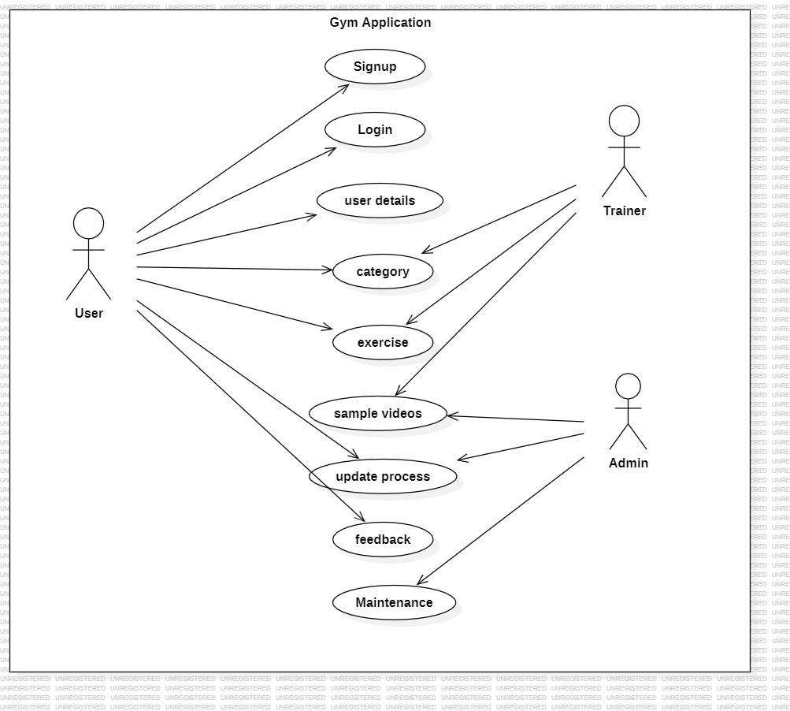

FIG.5.1 USE CASE DIAGRAM

## SEQUENCE DIAGRAM

A sequence diagram is a visual representation used in software engineering to illustrate the interactions between objects or components in a system. It depicts the order and flow of messages or method calls between these entities, showing how they collaborate to achieve a specific functionality.They help in identifying communication patterns, dependencies, and potential issues in the software's execution. Overall, sequence diagrams are a vital tool for modeling and documenting the interaction between elements in a software system.

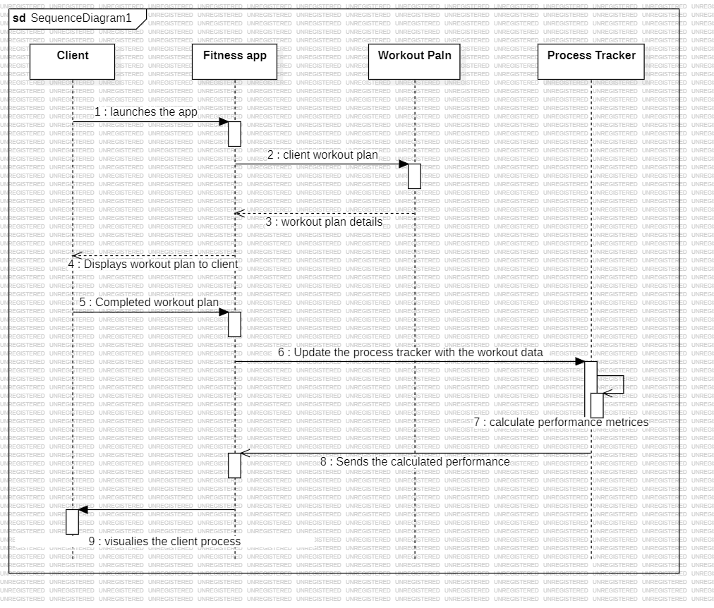

FIG.5.2 SEQUENCE DIAGRAM

## METHODOLOGIES USED IN OUR APP

**5.3.1 User Authentication and Authorization**

This phase encompasses the processes of user registration, login, and session management. It ensures that users can securely create accounts, log in, and access their personalized features.

**5.3.2 Workout Information Management**

In this phase, we focus on displaying comprehensive workout information to users. This includes details such as exercise details, sample videos and completed status.

## 

## 5.3.3 Admin Dashboard

The admin dashboard grants administrators special privileges for managing user details, including exercise list, workout category, trainer details, feedback and sample videos.

## 5.4 ENROLLMENT PHASE

* + 1. **Signup page**

The signup page allows users to create a new account on the platform. It collects essential personal information, such as name, email, and password. Passwords are securely stored using encryption to ensure data security.

## Login page

The login page enables registered users to access their accounts using their email and password. The system authenticates the user's credentials by comparing the entered password with the stored encrypted password.

## 5.5 NAVIGATION PHASE

* + 1. **Home page**

The home page serves as the main entry point of the application. Users can access different sections of the platform, such as categories, profiles, or privacy policy, directly from the home page. The design and layout of a home page aim to deliver a user-friendly experience.

## User information page

This page offers users to add the extra information like age, weight, height, goal. It will be stored in the profile and also calculated for preparing workout to be practiced.

## Workout Category page

It provides users with an easy way to explore and select workouts that align with their fitness goals or preferences. Common workout categories may include strength training, cardio, yoga, HIIT, and flexibility.

## Exercise page

Exercise pages are essential resources for users seeking guidance on how to perform exercises accurately and safely within their fitness routines. These pages often include information about the muscle groups targeted, equipment required, and variations to cater to different fitness levels.

## Sample videos page

Users can access exercise pages to learn how to perform specific movements correctly, helping to prevent injuries and maximize workout effectiveness. It will be useful for the users to learn easily.

## 

## Progress tracker page

It designed for tracking and managing various progresses and workflows. This page typically offers users an overview of ongoing progresses, their status, and critical milestones.

## Help and Support page

This page aims to provide users with the information and tools they need to resolve issues and find answers to common questions, ultimately enhancing their experience and usability of the platform.

## 5.6 MICROSERVICE PHASE

* + 1. **Feedback page**

A feedback page is a section within application that invites users to provide their opinions, suggestions, or comments about their experiences using the platform. Feedback will be used and protected is often included about data privacy.

**CHAPTER 6**

**IMPLEMENTATION AND RESULT**

This chapter gives a description about the output that we produced by developing the website of our idea.

## 6.1 LOGIN PAGE

The login page enables registered users to access their accounts using their email and password. The system authenticates the user's credentials by comparing the entered password with the stored encrypted password.

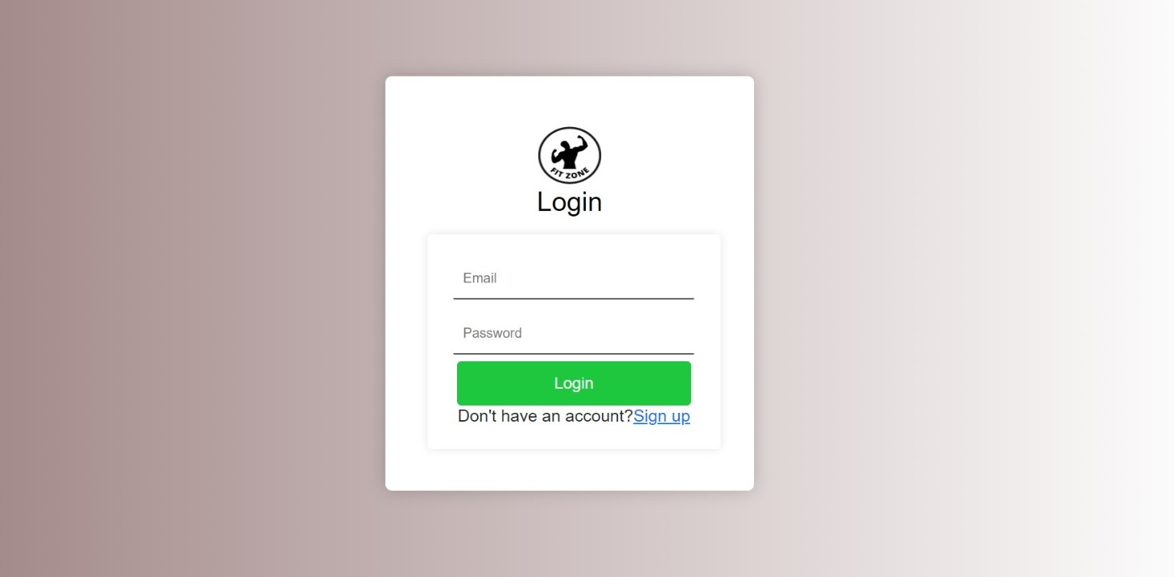

FIG.6.1 LOGIN PAGE

## 6.2 HOME PAGE

The home page serves as the main entry point of the application. Users can access different sections of the platform, such as categories, profiles, or privacy policy, directly from the home page.



FIG.6.2 HOME PAGE

## 6.3 WORKOUT CATEGORY PAGE

It provides users with an easy way to explore and select workouts that align with their fitness goals or preferences. Common workout categories may include strength training, cardio, yoga, HIIT, and flexibility.

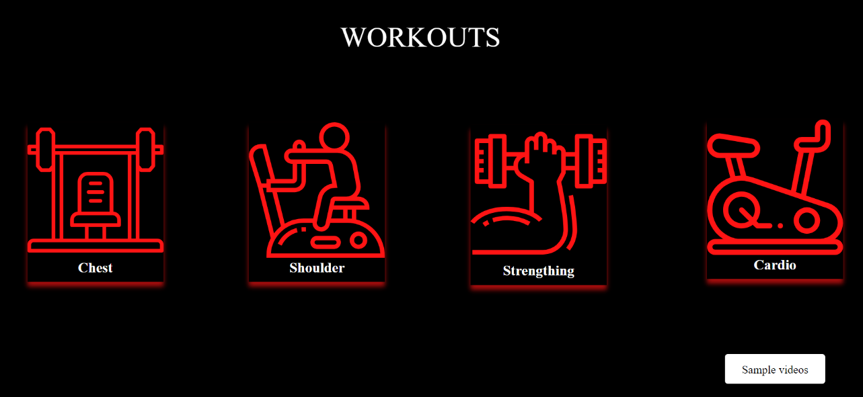

FIG.6.3 WORKOUT CATEGORY PAGE

## 6.4 EXERCISE PAGE

Exercise pages are essential resources for users seeking guidance on how to perform exercises accurately and safely within their fitness routines.

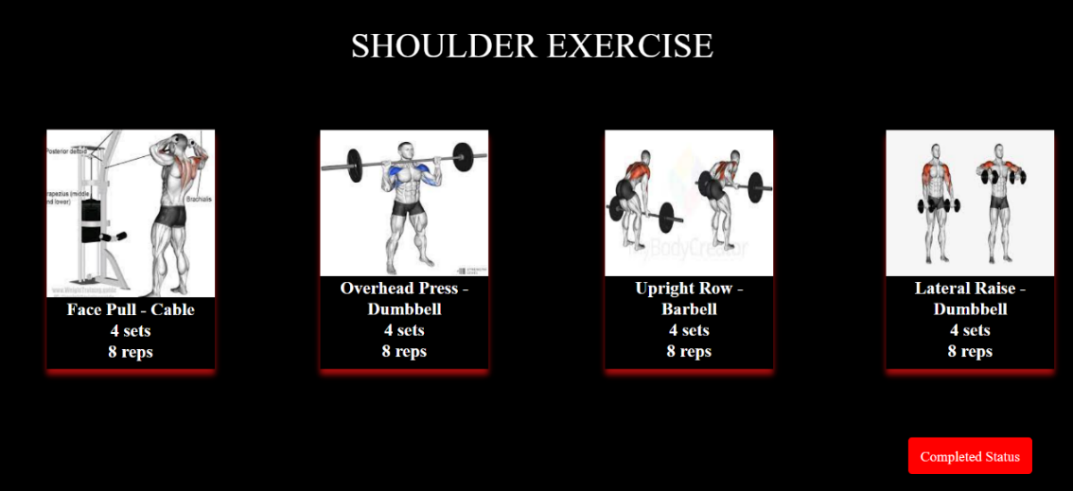

FIG 6.4 EXERCISE PAGE

## 6.5 SAMPLE VIDEOS PAGE

Users can access exercise pages to learn how to perform specific movements correctly, helping to prevent injuries and maximize workout effectiveness. It will be useful for the users to learn easily.

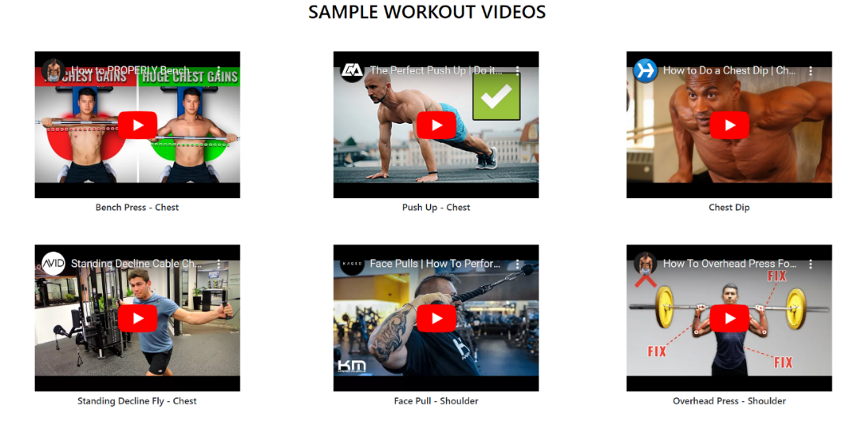

FIG 6.5 SAMPLE VIDEOS PAGE

## 6.6 HELP AND SUPPORT PAGE

This page aims to provide users with the information and tools they need to resolve issues and find answers to common questions, ultimately enhancing their experience and usability of the platform.

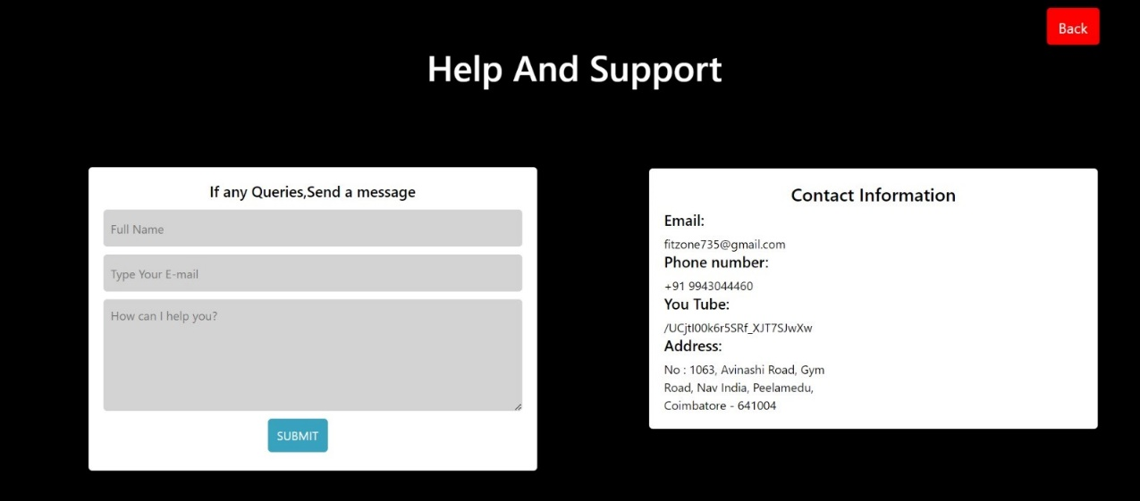

FIG 6.6 HELP AND SUPPORT PAGE

## CODING

**HOME PAGE**

import React from 'react';

import "./Styles/home.css";

import store from './store';

import { Link, useNavigate } from 'react-router-dom';

import logo1 from '../1.png'

const Home = () => {

const name = store.getState().name.name;

console.log(name)

const nav = useNavigate()

const Join = () => {

nav("/UserDataForm")}

return (

<div className='home1_aa'>

<div className="home1_dashboard">

<nav className="home1_navbar">

<img className="logo1"

src={logo1}

alt=""

srcset=""/>

<h1 style={{marginLeft:'-420px'}}>FIT ZONE</h1><ul><Link style={{textDecoration:'none',color:'white'}} to="/home"><li>Home</li></Link>

<Link

style={{textDecoration:'none',color:'white'}} to="/about"><li>About Us</li></Link>

<Link style={{textDecoration:'none',color:'white'}} to="/Userprofile"><li>Profile</li></Link>

<Link style={{textDecoration:'none',color:'white'}} to="/"><li>Logout</li></Link>

</ul></nav>

<div className='textbox'>

<h5 className='home1_jj'>JUST ONE MORE,</h5>

<h3 className='home1_oo'>ONE MORE SET.</h3>

<button className='home1_button1' onClick={Join}>Join now</button>

<div className='home1_footer'>

<div className='home1_footer_privacy'>

<ul style={{listStyle:"none"}}>

<Link

style={{textDecoration:'none',color:'white',position:'absolute'}} to="/terms"><li>Terms and Conditions</li></Link>

<Link style={{textDecoration:'none', color:'white',position:'absolute'}} to="/privacy"><li style={{marginLeft:'230px'}}>Privacy Policy</li></Link>

<Link style={{textDecoration:'none', color:'white',position:'absolute'}} to="/helpandsupport"><li style={{marginLeft:'230px'}}>Help & Support

</li></Link> </ul></div>

</div>

</div>

</div>

</div>

);

};

export default Home;

**CHAPTER 7**

# CONCLUSION

This chapter tells about the conclusion that anyone can drive from the project and the learning we learnt by taking over this project.

## CONCLUSION

In conclusion, the journey of developing and implementing our gym application has been a testament to innovation, perseverance, and ultimate success. Through meticulous planning and unwavering dedication, we have crafted a platform that not only meets but surpasses the expectations of our users. Our commitment to a user-centric design is evident in the intuitive interface that facilitates seamless navigation and encourages engagement. a gym application serves as an indispensable tool for fitness enthusiasts and gym-goers. It offers numerous benefits, both for individuals and gym owners. For users, it provides a convenient way to track their workouts, set fitness goals, and monitor progress. Additionally, it often includes features like exercise tutorials, nutrition guidance, and social connectivity, enhancing the overall fitness experience. However, it is crucial to design a gym application that is user-friendly, visually appealing, and equipped with accurate tracking capabilities to meet the expectations of today's tech-savvy fitness community. Ensuring data security and privacy is also paramount in building trust with users. Gym owners can benefit from these applications as well, as they streamline administrative tasks such as membership management, class scheduling, and payment processing.

This is also better for engagement with members through communication features and enable data-driven decision-making to improve the gym's services. In essence, our household ecommerce website is a dynamic space that evolves with the needs of our users. a well-designed gym application can significantly enhance the fitness journey for individuals and help gym owners manage their facilities more efficiently, making it a valuable asset in the modern fitness landscape.

## 7.2 FUTURE SCOPE

Looking ahead, the future scope for our Gym trainer and Process tracker application is promising and multifaceted. Our commitment to excellence does not conclude with the current project; rather, it extends into a phase of continuous enhancement and expansion. Gym trainer applications can leverage artificial intelligence (AI) to provide more personalized workout plans, nutrition recommendations, and real-time feedback based on user data and performance. This can lead to more effective and engaging fitness experiences. The integration of virtual reality can take fitness training to the next level. Users could participate in immersive workouts or compete with others in virtual environments, enhancing motivation and engagement. Gym trainer apps can further integrate with wearable devices like smartwatches and fitness trackers to gather more comprehensive data about a user's health and fitness. This data can be used to offer tailored training plans and monitor progress more effectively. AI-driven progress trackers can help users predict bottlenecks and optimize processes by analyzing historical data and providing actionable insights. We will make it easier for users to understand and manage complex workflows and tasks and sample videos. It will help to gain fitness.

## REFERENCES

* + 1. W3Schools, "HTML Tutorial" - Available at: <https://www.w3schools.com/html/>
    2. MDN Web Docs, "CSS Tutorial" - Available at: [CSS: Cascading Style Sheets| MDN (mozilla.org)](CSS:%20Cascading%20Style%20Sheets|%20MDN%20(mozilla.org))
    3. React documentation: <https://legacy.reactjs.org/docs/getting-started.html>
    4. React for Beginners: <https://www.freecodecamp.org/news/get-started-withreact-for-beginners/>
    5. Full-Stack React: <https://www.geeksforgeeks.org/full-stack-developmentwith-react-node-js-live/>
    6. JavaScript MDN Web Docs, "JavaScript Guide" - Available at: <https://developer.mozilla.org/en-US/docs/Web/JavaScript/Guide>
    7. ReactJS Official Documentation - Available at: [Getting Started – React (reactjs.org)](Getting%20Started%20–%20React%20(reactjs.org))
    8. Node.js Official Documentation - Available at: [Documentation | Node.js (nodejs.org)](Documentation%20|%20Node.js%20(nodejs.org))
    9. Gym application extra design : <https://dribbble.com/tags/gym_app>
    10. Customer Support for gym application : <https://www.glofox.com/blog/importance-of-customer-service-in-fitness-industry/>